ASSIGNMENT 8
DIVANSHI GARG (1024030441)

Q1) 1. Write program using functions for binary tree traversals: Pre-order, In-order and Post order using recursive approach
#include <iostream>
using namespace std;

struct Node {
int data;
Node* left;
Node* right;

Node(int value) {
data = value;
left = right = NULL;
}
};

void preorder(Node* root) { // Root → Left → Right
if (root == NULL) return;
cout << root->data << " ";
preorder(root->left);
preorder(root->right);
}

void inorder(Node* root) { // Left → Root → Right
if (root == NULL) return;
inorder(root->left);
cout << root->data << " ";
inorder(root->right);
}

void postorder(Node* root) { //Left → Right → Root
if (root == NULL) return;
postorder(root->left);
postorder(root->right);
cout << root->data << " ";
}

int main() {
Node* root = new Node(1);
root->left = new Node(2);
root->right = new Node(3);
root->left->left = new Node(4);
root->left->right = new Node(5);
root->right->left = new Node(6);
cout << "Preorder Traversal: ";
preorder(root);
cout << endl;

cout << "Inorder Traversal: ";
inorder(root);
cout << endl;

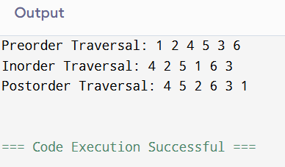
cout << "Postorder Traversal: ";
postorder(root);
cout << endl;

return 0;
}
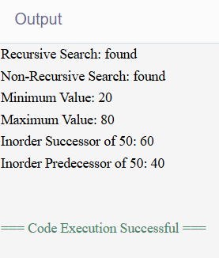
Q2) 2. Implement following functions for Binary Search Trees (a) Search a given item (Recursive & Non-Recursive) (b) Maximum element of the BST (c) Minimum element of the BST (d) In-order successor of a given node the BST (e) In-order predecessor of a given node the BST
#include <iostream>
using namespace std;

struct Node {
int data;
Node* left;
Node* right;

Node(int value) {
data = value;
left = right = NULL;
}
};

Node* insert(Node* root, int value) {
if (root == NULL)
return new Node(value);

if (value < root->data)
root->left = insert(root->left, value);
else
root->right = insert(root->right, value);

return root;
}

Node* searchRecursive(Node* root, int num) {
if (root == NULL || root->data == num)
return root;

if (num < root->data)
return searchRecursive(root->left, num);
else
return searchRecursive(root->right, num);
}

Node* searchNonRecursive(Node* root, int key) {
while (root != NULL) {
if (key == root->data)
return root;
else if (key < root->data)
root = root->left;
else
root = root->right;
}
return NULL;
}

Node* findMin(Node* root) {
while (root && root->left)
root = root->left;
return root;
}

Node* findMax(Node* root) {
while (root && root->right)
root = root->right;
return root;
}

Node* inorderSuccessor(Node* root, int key) {
Node* current = searchNonRecursive(root, key);
if (!current) return NULL;

if (current->right)
return findMin(current->right);

Node* successor = NULL;
Node* ancestor = root;
while (ancestor != current) {
if (key < ancestor->data) {
successor = ancestor;
ancestor = ancestor->left;
} else {
ancestor = ancestor->right;
}
}
return successor;
}

Node* inorderPredecessor(Node* root, int key) {
Node* current = searchNonRecursive(root, key);
if (!current) return NULL;

if (current->left)
return findMax(current->left);

Node* predecessor = NULL;
Node* ancestor = root;

while (ancestor != current) {
if (key > ancestor->data) {
predecessor = ancestor;
ancestor = ancestor->right;
} else {
ancestor = ancestor->left;
}
}
return predecessor;
}

int main() {
Node* root = NULL;

int arr[] = {50, 30, 20, 40, 70, 60, 80};
int n = 7;

for (int i = 0; i < n; i++)
root = insert(root, arr[i]);

int key = 40;

cout << "Recursive Search: " ;
cout << (searchRecursive(root, key) ? "found" : "not found") << endl;

cout << "Non-Recursive Search: ";
cout << (searchNonRecursive(root, key) ? "found" : "not found") << endl;

cout << "Minimum Value: " << findMin(root)->data << endl;
cout << "Maximum Value: " << findMax(root)->data << endl;

Node* suc = inorderSuccessor(root, 50);
cout << "Inorder Successor of 50: "
<< (suc ? to_string(suc->data) : "None") << endl;

Node* pre = inorderPredecessor(root, 50);
cout << "Inorder Predecessor of 50: "
<< (pre ? to_string(pre->data) : "None") << endl;

return 0;
}

Q3) 3. Write a program for binary search tree (BST) having functions for the following operations: (a) Insert an element (no duplicates are allowed), (b) Delete an existing element, (c) Maximum depth of BST (d) Minimum depth of

#include <iostream>
using namespace std;

struct Node {
int data;
Node* left;
Node* right;

Node(int val) {
data = val;
left = right = nullptr;
}
};

Node* insert(Node* root, int val) {
if (!root) return new Node(val);
if (val < root->data)
root->left = insert(root->left, val);
else if (val > root->data)
root->right = insert(root->right, val);
return root;
}

Node* findMin(Node* root) {
while (root && root->left)
root = root->left;
return root;
}

Node* deleteNode(Node* root, int val) {
if (!root) return nullptr;

if (val < root->data)
root->left = deleteNode(root->left, val);
else if (val > root->data)
root->right = deleteNode(root->right, val);
else {
if (!root->left) {
Node* temp = root->right;
delete root;
return temp;
}
else if (!root->right) {
Node* temp = root->left;
delete root;
return temp;
}
Node* temp = findMin(root->right);
root->data = temp->data;
root->right = deleteNode(root->right, temp->data);
}
return root;
}

int maxDepth(Node* root) {
if (!root) return 0;
return 1 + max(maxDepth(root->left), maxDepth(root->right));
}

int minDepth(Node* root) {
if (!root) return 0;
if (!root->left) return 1 + minDepth(root->right);
if (!root->right) return 1 + minDepth(root->left);
return 1 + min(minDepth(root->left), minDepth(root->right));
}

void inorder(Node* root) {
if (!root) return;
inorder(root->left);
cout << root->data << " ";
inorder(root->right);
}

int main() {
Node* root = nullptr;
int arr[] = {50, 30, 70, 20, 40, 60, 80};
for (int x : arr)
root = insert(root, x);

cout << "Inorder BST: ";
inorder(root); cout << endl;

cout << "Max Depth: " << maxDepth(root) << endl;
cout << "Min Depth: " << minDepth(root) << endl;

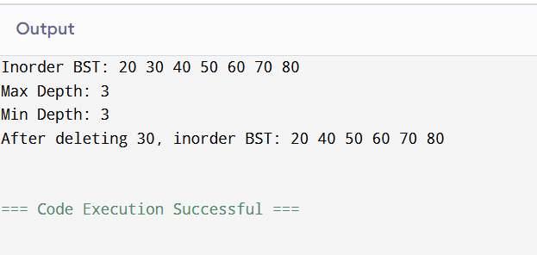
root = deleteNode(root, 30);
cout << "After deleting 30, inorder BST: ";
inorder(root); cout << endl;

return 0;
}

Q4) Write a program to determine whether a given binary tree is a BST or not.
#include <iostream>
using namespace std;

struct Node {
int data;
Node* left;
Node* right;
Node(int d) {
data = d;
left = right = NULL;
}
};

bool isBSTUtil(Node* root, int min, int max) {
if (root == NULL) return true;

if (root->data <= min || root->data >= max)
return false;

return isBSTUtil(root->left, min, root->data) &&
isBSTUtil(root->right, root->data, max);
}

bool isBST(Node* root) {
return isBSTUtil(root, -999999, 999999);
}

int main() {
Node* root = new Node(50);
root->left = new Node(30);
root->right = new Node(70);
root->left->left = new Node(20);
root->left->right = new Node(40);

if (isBST(root))
cout << "Tree is a BST";
else
cout << "Tree is NOT a BST";

return 0;
}

Q5) Implement Heapsort (Increasing/Decreasing order).
#include <iostream>
using namespace std;

void heap(int arr[], int n, int i) {
int largest = i;
int l = 2*i + 1;
int r = 2*i + 2;

if (l < n && arr[l] > arr[largest])
largest = l;

if (r < n && arr[r] > arr[largest])
largest = r;

if (largest != i) {
int temp = arr[i];
arr[i] = arr[largest];
arr[largest] = temp;
heap(arr, n, largest);
}
}

void heapSort(int arr[], int n) {
for (int i = n/2 - 1; i >= 0; i--)
heap(arr, n, i);

for (int i = n-1; i >= 0; i--) {
int temp = arr[0];
arr[0] = arr[i];
arr[i] = temp;

heap(arr, i, 0);
}
}

int main() {
int arr[6] = {12, 11, 13, 5, 6, 7};
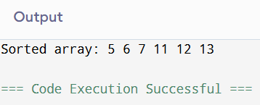
int n = 6;

heapSort(arr, n);

cout << "Sorted array: ";
for (int i = 0; i < n; i++)
cout << arr[i] << " ";
}

Q6) Implement priority queues using heaps.
#include <iostream>
using namespace std;

class PriorityQueue {
int heap[100];
int size;

public:
PriorityQueue() {
size = 0;
}

void push(int val) {
heap[size] = val;
int i = size;
size++;

// heapify up
while (i != 0 && heap[(i-1)/2] < heap[i]) {
int temp = heap[i];
heap[i] = heap[(i-1)/2];
heap[(i-1)/2] = temp;
i = (i-1)/2;
}
}

int top() {
return heap[0];
}

void pop() {
if (size == 0) return;

heap[0] = heap[size-1];
size--;

// heapify down
int i = 0;
while (true) {
int l = 2*i + 1;
int r = 2*i + 2;
int largest = i;

if (l < size && heap[l] > heap[largest])
largest = l;
if (r < size && heap[r] > heap[largest])
largest = r;

if (largest == i) break;

int temp = heap[i];
heap[i] = heap[largest];
heap[largest] = temp;

i = largest;
}
}

bool empty() {
return size == 0;
}
};

int main() {
PriorityQueue pq;

pq.push(10);
pq.push(50);
pq.push(20);

cout << "Max: " << pq.top() << endl;
pq.pop();
cout << "Next Max: " << pq.top() << endl;

return 0;
}

